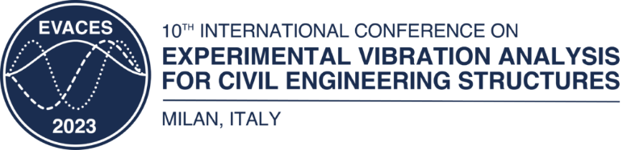

**SPECIAL SESSION TITLE**

### **First Organizer [0000-1111-2222-3333]**



#### Affiliation, address

#### E-mail address

Picture of the first organizer

### **First Organizer [0000-1111-2222-3333]**



#### Affiliation, address

#### E-mail address

Picture of the second organizer

**Keywords:** 3-5 keywords

**1 SPECIAL SESSION PROPOSAL**

A special session includes at least six coordinated presentations on a single topic of substantial current interest. The organizers will contact the speakers they wish to invite to their session and will provide suitable reviewers to check the quality of the papers before acceptance for presentation during the session. The conference committee and co-chairs will assist the organizers in managing the review process. The organizers must be available to chair their sessions during the conference and create discussion opportunities. They should make no financial commitments on behalf of EVACES 2023 to any speakers when organizing their special sessions.

**1.1 Submission**

Participants interested in organizing a special session are invited to submit a proposal **no later than June 30, 2022**. *Please send your proposal to the EVACES 2023 organizing committee via e-mail (evaces2023@polimi.it)*. The acceptance of the proposal will be communicated to the organizers soon after the deadline.

* 1. **Guidelines**

The proposal should outline the main features of the special session and be written in a way that is accessible to specialists as well as non-specialists. The scope of the special session should be clear and explain the problem area and the topics to address. The proposal must not be longer than half a page and must not include figures or tables.